Internship Training Report
on
Hydrocracking of VGO into Lighter Distillates



INDIAN OIL CORPORATION LTD.
Research and Development Centre, Faridabad

A PROJECT REPORT
Submitted in partial fulfillment for the award of the degree of

Bachelor of Technology

in

PETROLEUM ENGINEERING

by
SAPNA KUMARI

Under the guidance of

Mr. PAPPU NARESH (SRM)



ACKNOWLEDGEMENT

I am using this opportunity to express my gratitude to everyone who supported me throughout the Course of this Vocational Training. I am thankful for their aspiring guidance, invaluably constructive Criticism and friendly advice during the project work.

I express earnest gratitude to Indian Oil Corporation Research and Development Centre, Faridabad for giving me this opportunity. At the very outset, I would like to express my gratitude from bottom of my heart to Mr. KARUMANCHI RAMESH, GM (HD) IOCL R&D Centre, for giving me the opportunity to do my Summer Internship Project in this esteemed organization.

I articulate my sincere gratitude to my project Mentor and guide Mr. MAINAK SARKAR (DGM-HC) and Mr. PAPPU NARESH (SRM), IOCL R&D Centre who has spent his valuable time and guided me throughout the training process in spite his busy schedule, in shaping of my project. I duly acknowledge each and every staff member of Hydroprocessing Division for giving me such a vast ocean of knowledge and such a deferential project to be accomplished with.

Table of Contents
S.No | Contents | Page No
1. | Introduction to Indian Oil | 5
1.1. | Introduction to R&D Center | 5
1.2. | Refining Technology | 6
1.3. | Products and Services | 6
2. | Overview of Petroleum Refinery | 9
2.1. | Petroleum Refining | 9
2.2. | Crude Oil | 10
2.2.1. | Composition of Crude oil | 10
2.2.2. | Selection Of Crude Oil | 10
2.2.3. | Pre Treatment Of Crude oil | 11
2.3. | Separation Process | 12
2.3.1. | Atmospheric Distillation | 12
2.3.2. | Vacuum Distillation | 14
2.4. | Conversion Processes | 15
2.4.1. | Isomerization | 15
2.4.2. | Catalytic Reforming | 16
2.4.3. | Alkylation | 17
2.4.4. | Hydrocracking | 17
2.4.5. | Fluid Catalytic Cracking | 18
2.4.6. | Delayed Coking | 19
2.4.7. | Visbreaking | 19
3. | Hydroprocessing | 20
3.1. | Hydro Treating | 22
3.2. | Hydrocracking | 26
4. | Experimental Analysis | 32
4.1. | Catalyst Loading | 32
4.2. | Catalyst Loading Procedure | 34
5. | Safety Consideration in Petroleum Refining | 36
5.1. | Hazards in petroleum Refinery | 36
5.2. | Safety Programs and Regulations | 38
5.3. | Hazard Analysis | 39
5.4. | Safe Operation System | 41
6 | Major Refinery Products and their Specifications | 43

- Introduction to Indian Oil
  - Introduction to R&D Centre
IndianOil's world-class Research & Development is focused on developing, demonstrating and deploying novel, innovative, environment friendly, customer centric products and process technologies for addressing issues of national importance to attain self-reliance in field of energy and allied areas. Apart from carrying out path breaking research in core petroleum activities like Lubricants, Refining, Petrochemicals and Pipeline; IndianOil R&D is pursuing pioneering work in promising & futuristic Alternate Energy segments like Bio-Energy, Solar Energy, Hydrogen, Energy Storage, Battery, CCU Technologies etc.
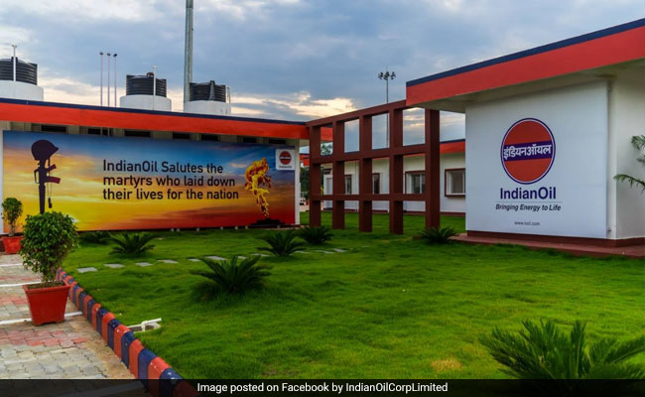
The state-of-the-art Research & Development facilities is located on a sprawling 65 acre campus in Faridabad, Haryana on the outskirts of the National Capital. An impressive array of most advanced equipment is available to experienced researchers and scientists round-the-clock.
IndianOil is first to achieve the milestone of 1000 patents filed among Indian Oil & Gas companies. IndianOil has won recognition for decades of pioneering work in fields of lubricants formulation, refinery processes, pipeline transportation/ maintenance and alternative fuel technologies. To further expand its footprint, IndianOil is planning to set up a net-zero power & water neutral research centre confirming to global level, consisting of following high end research centers :
- IndianOil Centre for Alternative & Renewable Energy (I-CARE)
- IndianOil Centre for Corrosion Research
- IndianOil Centre of Excellence in Nanotechnology
- IndianOil Centre of Excellence in Synthetic Biology

IndianOil with its consistent efforts has now achieved the status of refining technology exporter in a very competitive field, by licensing the INDMAX technology to global customers besides existing units in domestic refineries.

  - Refining Technology

Research & Development of IndianOil has established a prominent footprint in Refining Technology area. It has demonstrated its innovative prowess in development of basket of technologies, highly relevant in the emerging scenario, and their successful commercialization.
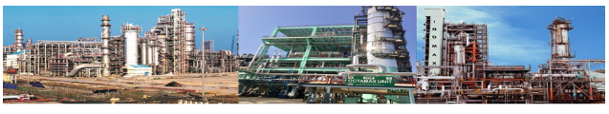
Most of these technologies have been demonstrated at IndianOil refineries and currently are in regular operation contributing to the gross refining margin.

For all its technologies, IndianOil on its own or through its technology partner provides a single point solution for technology licensing, including supply of Basic Design and Engineering Package (BDEP), catalyst, reactor internal, mandatory technical services, etc. as per the standard industry practice.

  - Products and Services

    - Lubricants
Over 1000 grades of lubricants developed by R&D are marketed under the super lubricant brand name "SERVO" encompassing every conceivable application for complete lubrication solutions in the automotive, industrial and marine segments. The centre further act as a solution provider to the rising demand for innovative lubricants to achieve fuel economy & energy efficiency, especially for the Indian Defense Forces by indigenising the specialised products.

    - Petrochemicals and Polymers
Over 1000 grades of lubricants developed by R&D are marketed under the super lubricant brand name "SERVO" encompassing every conceivable application for complete lubrication solutions in the automotive, industrial and marine segments. The centre further act as a solution provider to the rising demand for innovative lubricants to achieve fuel economy & energy efficiency, especially for the Indian Defense Forces by indigenising the specialised products.

    - Fuels and Additives
IndianOil Research & Development works consistently to enhance quality of fuels by incorporating additives to improve engine performance and to reduce environmental impact with improved quality and cost effectiveness.

New patented process technologies and novel chemistry additives are developed to improve quality of existing fuels and to produce next generation high performance products as Indane Nanocut, Premium automotive fuels, Marpol 2020 compliant FO for marine applications and special fuels for defense forces.

    - Alternate Energy
IndianOil R&D is working for development, deployment and harnessing of different alternative energy sources like Hydrogen Fuel Cell, H-CNG and Solar Energy. IndianOil R&D has developed cost effective single step compact Steam Methane Reforming process for direct HCNG production from NG which is flexible and rugged allowing H-CNG production as per demand, by-passing energy intensive electrolysis process and costly high pressure blending.

Solar Energy Department has state-of-the-art laboratory infrastructure such as a Solar Photovoltaic Rooftop Test Bed Facility, Solar Product Development and Cooking Systems Laboratory, Solar Thermal Research Laboratory and Solar Hydrogen Laboratory, for development & validation of new technologies.

    - Bio- Energy
The GoI through the initiatives taken under Bio-Fuel Policy 2018 has identified Ethanol Blending as a potent solution to stubble burning issue with possibility to increase farmers' income. IOCL has developed new and economical enzymatic pre-treatment process at pilot level using agriculture waste and is now scaling it up in demo plant at Panipat.

IOCL R&D is also working on a bio-route to convert the Co2 from refinery flue gases to Ethanol by installing India's first of its kind Co2 to Ethanol production plant at Panipat.

IndianOil has developed a two stage anaerobic processes for converting various types of organic wastes to biogas with ability to produce 15-20% more methane than other contemporary technologies and higher gas yield.

    - Nanotechnology
The thrust of Nanotechnology research in IndianOil Research & Development is to develop nano-materials, nanofluids and catalysts for applications in fuels, lubricants, processes & alternate energy segments including energy storage devices. Some of the game changing solutions developed by Centre are nano-dispersions agents for use in fuels and lubricants.
Indane Nanocut LPG is a commercialized product developed at R&D, which enhances the efficiency of LPG as cutting gas in terms of high flame temperature, heat through put, low oxygen consumption, reduced cylinder inventory, thereby leading to better economy of use.

    - E- Mobility
Research & Development is pursuing cutting edge research in the field of advanced battery chemistries to develop India specific energy storage solutions in a cost effective manner using indigenously available materials for development of Metal Air batteries and chemically modified lead acid batteries with improved capacity and life cycle.

    - IndS_UP StartUp Scheme
Research & Development has been involved in incubation of projects through the IOCL IndS_UP StartUp Scheme. Under this scheme till date 24 Projects are on boarded in 2 rounds with filing of 11 Joint patents & 6 Copyrights thus generating IP wealth for IOCL.

Major areas of funding/ support are artificial intelligence, Robotics, Societal relevance, pipeline surveillance & maintenance etc. Besides funding, IndianOil is being closely involved by handholding the identified StartUPs through dedicated Process Owners till achievement of Proof of Concept.

    - Pipes Maintenance and Inspection
R&D has been undertaking pioneering research in the areas of pipeline transportation and development of pipeline inspection tools (an area hitherto dominated by foreign companies) like MFL (magnetic flux leakage) based IPIG technology, gas pipeline inspection tool, advanced sensors for liquid pipeline inspection, Artificial Neural Network based Data analysis software and Integration of Inertial Measurement Unit for obtaining GPS coordinates.

Transportation of neat Bio fuel and its blends, compressed Biogas as well as carbon dioxide through cross country pipeline are identified for research work in near future. Research & Development and Pipeline Division of IOCL are working together to create the in-house operational expertise for large scale deployment of these technologies.

2.Overview of Petroleum Refinery
2.1. Petroleum Refining
The petroleum refining industry converts crude oil into more than 2500 refined products, including liquefied petroleum gas, gasoline, kerosene, aviation fuel, diesel fuel, fuel oils, lubricating oils, and feed stocks for the petrochemical industry. Petroleum refinery activities start with receipt of crude for storage at the refinery, include all petroleum handling and refining operations, and they terminate with storage preparatory to shipping the refined products from the refinery.
The petroleum refining industry employs a wide variety of processes. A refinery’s processing flow scheme is largely determined by the composition of the crude oil feedstock and the chosen slate of petroleum products. The arrangement of these processes will vary among refineries, and few, if any, employ all of these processes.
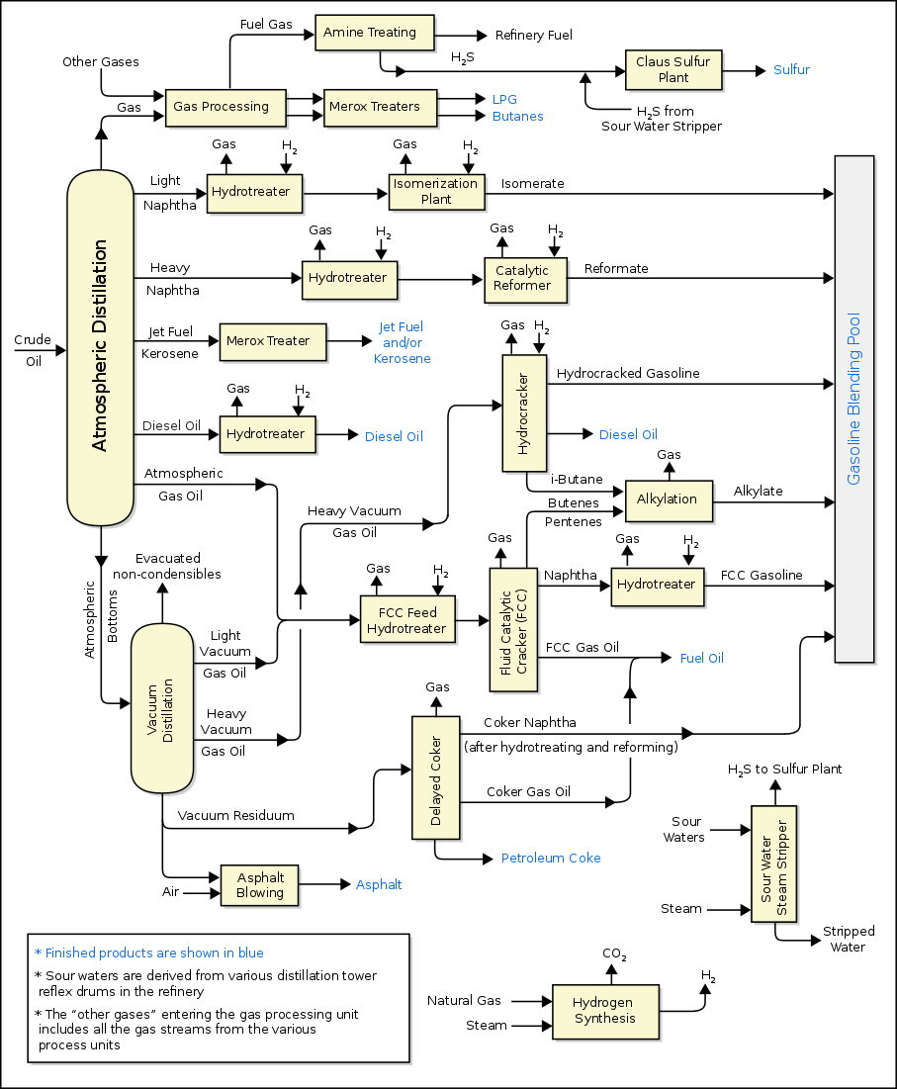
Figure 1. Flow diagram depicting Petroleum Refinery Processes

2.2 Crude oil
2.2.1. Composition of crude oil
Crude oil is a complex liquid mixture made up of a vast number of hydrocarbon compounds that consist mainly of carbon and hydrogen in differing proportions. In addition, small amounts of organic compounds containing Sulphur, oxygen, nitrogen and metals such as vanadium, nickel, iron and copper are also present. Hydrogen to carbon ratio affect the physical properties of crude oil. As the hydrogen to carbon ratio decreases, the gravity and boiling point of hydrocarbon compound increases. Moreover, the higher the hydrogen to carbon ratio of the feedstock, the higher its value is to a refinery because less hydrogen is required.
The composition of crude oil, on an elemental basis, falls within certain ranges regardless of its origin. Table 1 shows that carbon and hydrogen contents vary within narrow ranges. For this reason, crude oil is not contents vary within narrow ranges. For this reason, crude oil is not classified on basis of carbon content. Despite their lower concentrations, impurities such as Sulphur, nitrogen, oxygen and metals are undesirable because they cause concerns in the process ability of crude feedstock and because they affect the quality of the produced products. Catalyst poisoning and corrosion are the most noticeable effects during refining.
Table 1. Elemental Composition of crude oil

Element | Composition(wt%)
Carbon | 83.0-87.0
Hydrogen | 10.0-14.0
Sulphur | 0.05-6.0
Nitrogen | 0.1-0.2
Oxygen | 0.05-2.0
Nickel | <120 ppm
Vanadium | <1200 ppm
2.2.2. Selection of Crude Oil
The crude oil selected for further processing in the petroleum refining should be of great quality so that the finished products will also be of good quality and would be fit for use. The crude oil is selected on the following parameters:
- Total Acid Number (TAN) Value: The crude oil having a TAN value less than 0.5 is best for use as higher values of TAN number would result in increased quality of sulphur and would degrade the quality of the crude oil.
- Density: The selected crude oil should be of lighter density and should not form wax, otherwise it would be difficult to process the crude oil.
- American Petroleum Institute (API) Gravity: American Petroleum Institute (API) gravity is the measure of the weight of crude oil. API gravity is a measure of the weight of a crude oil in relation to water. Light crude oil with high API gravity is preferred due to the presence of a high proportion of light hydrocarbon fractions.
- Sulphur Content: Crude oil with low sulphur content is preferred because if the crude oil will have higher content of sulphur, it will produce greater emissions, particularly those emissions that are toxic and have a high global warming potential, and higher the sulfur count, the lower is the hydrocarbon count— hydrocarbons being the component in petroleum that combusts and generates energy.

2.2.3. Pre Treatment of Crude Oil
- Desalting process:
Crude oil often contains water, inorganic salts, suspended solids, and water-soluble trace metals. As a first step in the refining process, to reduce corrosion, plugging, and fouling of equipment and to prevent poisoning the catalysts in processing units, these contaminants must be removed by desalting (dehydration).
To remove the salt and the water, crude oil undergoes a step known as desalting. In this step the crude oil undergoes an initial dilution with the addition of clean water. The new diluted mixture is then emulsified so that the salty water initially present in the crude oil comes into contact with the clean water. The emulsion then enters the desalter which separates the emulsion into two separate layers, a layer of water and a layer of crude oil. Salt easily dissolves in water and because of this it is also separated along with the water.
- Desulfurization process:
The water is then sent to the water treatment system and the crude oil progresses to the next stage. The next stage is to desulfur the crude oil, this is important as this should reduce the emission of sulfur dioxide (SO2) when any fuel created in the fractional distillation is burnt.
Desulfurization requires heating and pressurizing the crude oil to specific conditions and then the addition of hydrogen gas. The addition of the hydrogen gas should cause a reaction with any sulfur present and form hydrogen sulfide (H2S). The hydrogen sulfide is then converted into elemental sulfur and hydrogen, the sulfur can be sold on as a by-product whereas the hydrogen can be recycled and used again in the previous step.
- Pre heating of crude oil:
The direct immersion in the crude oil allows for rapid heating with less wasted energy. This makes your process faster and reduces operational costs. The pre heating of crude oil reduces the viscosity of some kinds of crude oils and by that way improve the upstream separation performances.
2.3 Separation Process
2.3.1. Atmospheric Distillation Unit:
Crude oil is sent to the atmospheric distillation unit after desalting and heating. The purpose of atmospheric distillation is primary separation of various 'cuts' of hydrocarbons namely, fuel gases, LPG, naptha, kerosene, diesel and fuel oil. The heavy hydrocarbon residue left at the bottom of the atmospheric distillation column is sent to vacuum distillation column for further separation of hydrocarbons under reduced pressure.
As the name suggests, the pressure profile in atmospheric distillation unit is close to the atmospheric pressure with highest pressure at the bottom stage which gradually drops down till the top stage of the column.
The temperature is highest at the bottom of the column which is constantly fed with heat from bottoms reboiler. The reboiler vaporizes part of the bottom outlet from the column and this vapor is recycled back to the distillation column and travels to the top stage absorbing lighter hydrocarbons from the counter current crude oil flow. The temperature at the top of the column is the lowest as the heat at this stage of the column is absorbed by a condenser which condenses a fraction of the vapors from column overhead. The condensed hydrocarbon liquid is recycled back to the column. This condensed liquid flows down through the series of column trays, flowing counter current to the hot vapors coming from bottom and condensing some of those vapors along the way.

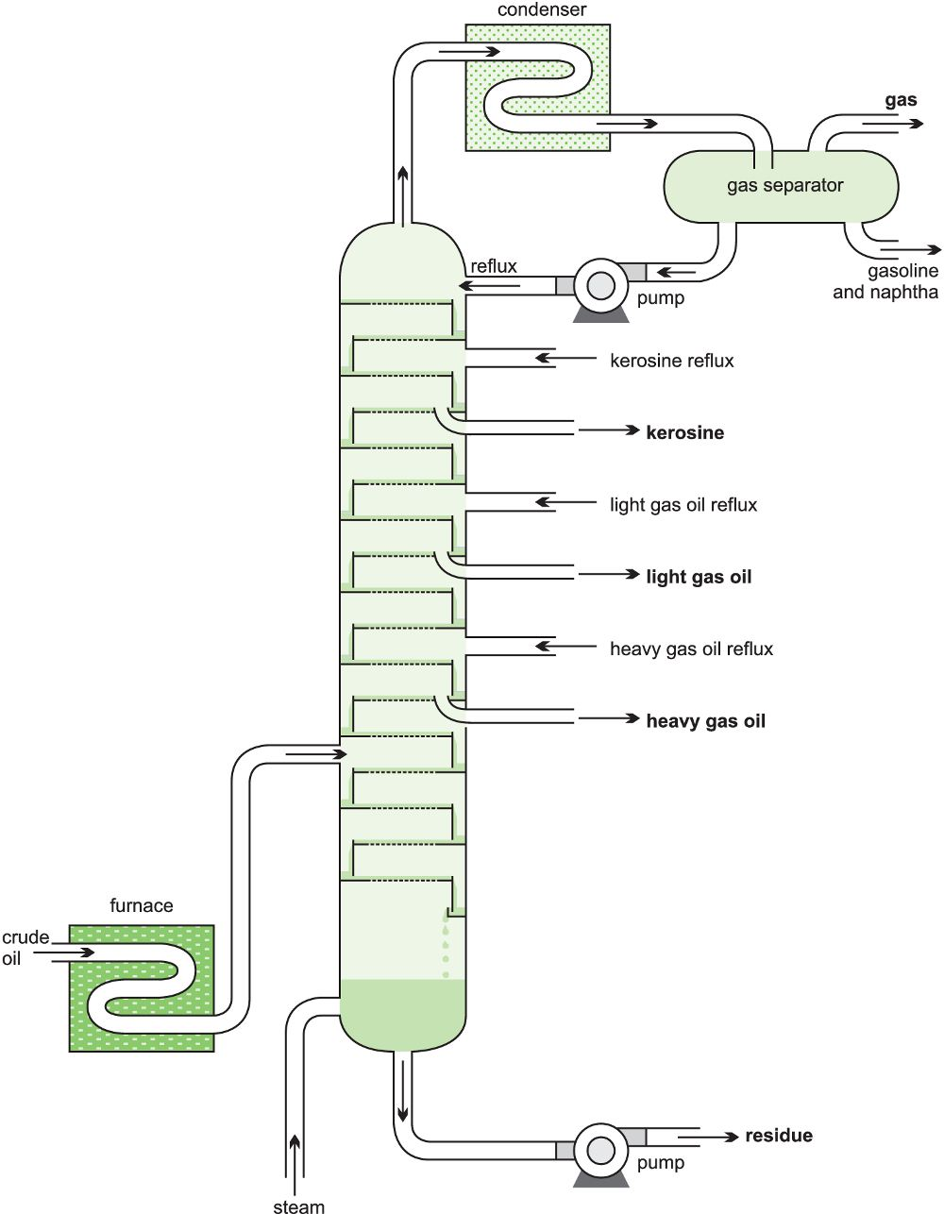 Figure 2. Atmospheric distillation unit
Thus a reboiler at the bottom and a condenser at the top along with a number of trays in between help to create temperature and pressure gradients along the stages of the column. The gradual variation of temperature and pressure from one stage to another and considerable residence time for vapors and liquid at a tray help to create near equilibrium conditions at each tray.
The heaviest hydrocarbons are taken out as liquid flow from the partial reboiler at bottom and the lightest hydrocarbons are taken out from the partial condenser at the column overhead. For the in between trays or stages, the hydrocarbons become lighter as one moves up along the height of the column. Various other cuts of hydrocarbons are taken out as sidedraws from different stages of the column. Starting from LPG at the top stages, naptha, kerosene, diesel and gas oil cuts are taken out as we move down the stages of atmospheric column.
The heaviest hydrocarbon residue taken out from partial reboiler is sent to the vacuum distillation column for further separation under reduced pressure. The different cuts of hydrocarbons taken out at this stage are the result of primary separation and undergo further processing before being transformed to end products.
Table 2. Atmospheric Distillation Unit products cuts at temperature and their Application
Distillation Column |  | Product | Temperature  cut | Carbon No | Application
Atmospheric  Column |  | Fuel gases | ˃40°C | C₁-C₂ | Fuel
 |  | LPG |  | C₃-C₄ | Domestic fuel
 |  | Straight Run Gasoline | 20-90 | C₆-C₁₀ | Gasoline pool
 |  | Naphtha  (medium & heavy) | 130-180 | C₆-C₁₀ | Catalytic  reforming and aromatic plant feed stock, Steam cracker synthesis gas manufacture
 |  | Kerosene | 180-270 | C₁₁-C₁₂ | Aviation turbine fuel,  LAB feed stock
 |  | Heavy gas oil | 270-380 | C₁₈-C₂₅ | High speed diesel

2.3.2. Vacuum Distillation Unit
Atmospheric Residue from the atmospheric distillation column are heated to approximately 400˚C in a fired heater and fed to the vacuum distillation column where they are fractionated into light gas oil, heavy gas oil and vacuum reside. Some heavy hydrocarbons cannot be boiled at the operating temperature and pressure conditions in the atmospheric distillation column. Hence they exit the bottom of the column in liquid state and are sent to the vacuum distillation column where they can be boiled at a lower temperature when pressure is significantly reduced. Absolute operating pressure in a Vacuum Tower can be reduced to 20 mm of Hg or less (atmospheric pressure is 760 mm Hg). In addition, superheated steam is injected with the feed and in the tower bottom to reduce hydrocarbon partial pressure to 10 mm of mercury or less. Lower partial pressure of the hydrocarbons makes it even more easier for them to be vaporized, thus consuming less heat energy for the process.
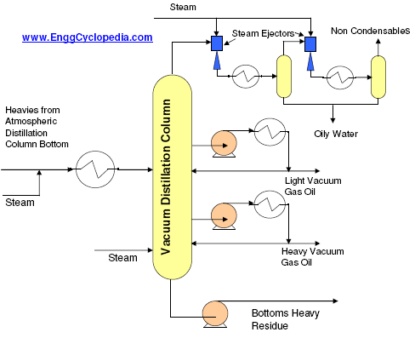
Figure 3. Vacuum Distillation

Two different cuts of hydrocarbons - 'light vacuum gas oil' and 'heavy vacuum gas oil' are separated in the vacuum distillation column at different stages of the column, based on the difference between their boiling point ranges. The liquid being drawn at low pressure needs to be pumped. Then it is heated and partially recycled back to the column. Part of is is taken out as vacuum distillation products - 'light vacuum gas oil' or 'heavy vacuum gas oil'. Light vacuum gas Oil is sent to a hydrotreater and then to a 'catalytic cracking' unit to obtain smaller chain hydrocarbons. Heavy vacuum gas oil is also sent for cracking using hydrogen in a 'hydrocracking unit' to produce smaller chain hydrocarbons.

Heavy hydrocarbons which cannot be boiled even under reduced pressure remain at the bottom of the column and are pumped out as 'vacuum residue'. The vacuum distillation column bottom residue can only be used for producing coke in a 'coker unit'.

Table 3. Vacuum Distillation Unit products cuts at temperature and their Application
Distillation Column |  | Product | Temperature  cut | Carbon No | Application
Vacuum  Column |  | Light vacuum  Gas | 370-425 | C18-C25 | Feed to FCC/HCU
 |  | Heavy vacuum  Gas | 425-550 | C26-C38 | Feed to FCC/HCU
 |  | Vacuum  Residue | >560 | ˃C38 | Bitumen

2.4. Conversion Processes
2.4.1. Isomerization
Isomerization is the process in which light straight chain paraffins of low RON (C6, C5 and C4) are transformed with proper catalyst into branched chains with the same carbon number and high octane numbers. The hydrotreated naphtha (HTN) is fractionated into heavy naphtha between 90–190 °C (190–380 F) which is used as a feed to the reforming unit. Light naphtha C5 - 80 °C (C5 - 180 F) is used as a feed to the isomerization unit. There are two reasons for this fractionation: the first is that light hydrocarbons tend to hydrocrack in the reformer. The second is that C6 hydrocarbons tend to form benzene in the reformer. Gasoline specifications require a very low value of benzene due to its carcinogenic effect.
Isomerization Catalyst: The most common catalyst for isomerising n-butane is platinum (Pt) on alumina promoted by chloride. The high activity of this catalyst allows operation at relatively low temperature. This is beneficial because the reaction is controlled by equilibrium; at low temperature, equilibrium favors isobutane. Pt/alumina catalysts can’t be regenerated, and they are highly sensitive to water and other contaminants.
In units that isomerize n-pentane and n-hexane, the reactions are catalyzed either by Pt/alumina or Pt on zeolite. The zeolite catalysts require higher temperatures, but they are less sensitive to water. As with butane isomerization, the reactions are controlled by equilibrium, so lower reaction temperatures favor branched isomers. The high temperatures required by zeolite catalysts reduce the octane of the product relative to products made at lower temperatures with chlorided alumina catalysts.

Table 4. Comparison of operating condition for isomerization
Operating Condition | Pt/ Chlorine Alumina  Catalyst | Pt/ Zeolite Catalyst
Temperature (oC) | 120-180 | 250-270
Pressure (bar) | 20-30 | 15-30
Space Velocity(h⁻¹) | 1-2 | 1-2
H₂/HC (mol/mol) | 0.1-2 | 2-4
Product RON | 83-84 | 78-80

2.4.2. Catalytic Reforming

Catalytic reforming is a process used to convert low-octane naphthas into high-octane gasoline blending components called reformates. Reforming is the total effect of several reactions that occur simultaneously including cracking, polymerization, dehydrogenation, and isomerization. Depending on the properties of the naphtha feedstock (as measured by the paraffin, olefin, naphthene, and aromatic content) and catalysts used, reformates can be produced with high concentrations of toluene, benzene, xylene, and other aromatics useful in gasoline blending and petrochemical processing. Hydrogen, a significant by-product, is separated from the reformate for recycling and use in other processes.
Some catalytic reformers operate at low pressure in the range of 50–200 psi, and others operate at high pressures up to 1000 psi. Some catalytic reforming systems continuously regenerate the catalyst in other systems. One reactor at a time is taken off-stream for catalyst regeneration, and some facilities regenerate all of the reactors during turnarounds.

Catalytic reforming Catalyst: Most catalytic reforming catalysts contain platinum or rhenium on a silica or silica-alumina support base, and some contain both platinum and rhenium. Fresh catalyst is chlorided (chlorinated) prior to use.
The noble metals (platinum and rhenium) are considered to be catalytic sites for the dehydrogenation reactions and the chlorinated alumina provides the acid sites needed for isomerization, cyclization and hydrocracking reactions. The biggest care has to be exercised during the chlorination. Indeed, if not chlorinated (or insufficiently chlorinated) the platinum and rhenium in the catalyst would be reduced almost immediately to metallic state by the hydrogen in the vapour phase. On the other hand, an excessive chlorination could depress excessively the activity of the catalyst.
The activity (i.e., effectiveness) of the catalyst in a semi-regenerative catalytic reformer is reduced over time during operation by carbonaceous coke deposition and chloride loss. The activity of the catalyst can be periodically regenerated or restored by in situ high temperature oxidation of the coke followed by chlorination. As stated earlier herein, semi-regenerative catalytic reformers are regenerated about once per 6 to 24 months. The higher the severity of the reacting conditions (temperature), the higher the octane of the produced reformate but also the shorter the duration of the cycle between two regenerations. Catalyst's cycle duration is also very dependent on the quality of the feedstock. However, independently of the crude oil used in the refinery, all catalysts require a maximum final boiling point of the naphtha feedstock of 180 °C.
Normally, the catalyst can be regenerated perhaps 3 or 4 times before it must be returned to the manufacturer for reclamation of the valuable platinum and/or rhenium content.

2.4.3. Alkylation
Alkylation, in petroleum refining, chemical process in which light, gaseous hydrocarbons are combined to produce high-octane components of gasoline. The light hydrocarbons consist of olefins such as propylene and butylene and isoparaffins such as isobutane. These compounds are fed into a reactor, where, under the influence of a sulfuric-acid or hydrofluoric-acid catalyst, they combine to form a mixture of heavier hydrocarbons. The liquid fraction of this mixture, known as alkylate, consists mainly of isooctane, a compound that lends excellent antiknock characteristics to gasolines.

2.4.4. Hydrocracking
Hydrocracking is a catalytic hydrogenation process in which high molecular weight feedstocks are converted and hydrogenated to lower molecular weight products. The catalyst used in hydrocracking is a bifunctional one. It is composed of a metallic part, which promotes hydrogenation, and an acid part, which promotes cracking. Hydrogenation removes impurities in the feed such as sulphur, nitrogen and metals. Cracking will break bonds, and the resulting unsaturated products are consequently hydrogenated into stable compounds.
It is mainly used to produce middle distillates of low sulphur content such as kerosene and diesel. If mild hydrocracking is used, a LSFO can be produced. More recently, it has been used to remove wax by catalytic dewaxing and for aromatic removal by hydrogen saturation. This has been applied to the lube oil plants and is gradually replacing the old solvent dewaxing and aromatic solvent extraction.
Hydrocracking Catalyst:
Hydrocracking catalysts have a cracking function and a hydrogenation–dehydrogenation function. The cracking function is provided by an acidic support, whereas the hydrogenation–dehydrogenation function is provided by active metals. The acidic support can be (a) amorphous oxides (e.g. silica–alumina), (b) a crystalline zeolite (mostly modified Y zeolite) plus binder (e.g. alumina) or (c) a mixture of crystalline zeolite and amorphous oxides. Cracking and isomerization reactions take place on the acidic support. The metals providing the hydrogenation–dehydrogenation function can be noble metals (palladium, platinum) or non-noble metal sulphides from Group VI.A (molybdenum, tungsten) and group VIII.A (cobalt, nickel). These metals catalyze the hydrogenation of the feedstock, making it more reactive for cracking and heteroatom removal and reducing the coking rate. They also initiate the cracking by forming a reactive olefin intermediate via dehydrogenation.
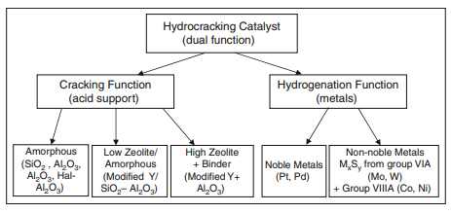
Figure 4. Classification of Hydrocracking catalyst
2.4.5. Fluidized Catalytic Cracking
The fluidised catalytic cracking (FCC) unit is the heart of the refinery and is where heavy low-value petroleum stream such as vacuum gas oil (VGO) is upgraded into higher value products, mainly gasoline and C3/C4 olefins, which can be used in the alkylation unit for production of ultraclean gasoline (C7–C8 alkylates). The FCC process has been in operation for over 60 years during which, a great deal of developments has occurred. Major developments have occurred in two areas: new catalysts and new reactor and regenerator designs.
The main feedstock used in a FCC unit is the gas oil boiling between 316 oC and 566 oC (600 oF and 1050 oF). This gas oil can be considered mixtures of aromatic, naphthanic and paraffinic molecules. There are also varying amounts of contaminants such as sulphur, nitrogen and metals particularly in the higher boiling fractions. Gas oil from residue and conversion processes (predominantly coking) can be fed to catalytic cracking units. They must be hydrotreated before catalytic cracking to separate aromatics and remove sulphur.
Table 5. Reactor and regenerator operating condition for max gasoline production
Condition | Range
Reactor Feed Rate, MBPSD | 40
Feed Temperature(oC) | 230
Catalyst/Oil Ratio | 5.4
Catalyst Circulation Rate, tons/min | 21.7
Catalyst Makeup Rate, tons/day | 2.5
Dispersion Steam, wt% feed | 0.9
Stripping Steam, tons/ton catalyst | 0.0213
Reactor Pressure, psig | 30
Regenerator Pressure, psig | 33
Regenerator Temperature(oC) | 727.22

The main reaction in the FCC is the catalytic cracking of paraffin, olefins, naphthenes and side chains in aromatics. A network of reactions occurring in the FCC. The VGO undergoes the desired ‘primary cracking’ into gasoline and LCO. A secondary reaction also occurs, which must be limited, such as a hydrogen transfer reaction which lowers the gasoline yield and causes the cycloaddition reaction. The latter could lead to coke formation.
The main catalyst which is used in a FCC reactor is the zeolite type. It is in a powder form with an average particle size of 75 mm and an average surface area of 800 m2/g. It has a crystalline structure of aluminosilicates. A matrix is added to the zeolite which acts as a binder and filler.
2.4.6. Delayed Coking
Delayed coking is a type of thermal cracking in which the heat required to complete the coking reactions is supplied by a furnace, while coking itself takes place in drums operating continuously on a 24 h filling and 24 h emptying cycles. The process minimizes residence time in the furnace, while sufficient time is allowed in the drums where coking takes place (hence the term ‘‘delayed coking.’’) Coke is rejected in the drums, thus increasing the H/C ratio in the rest of the products. However, these products are still unstable and unsaturated, and require further hydrogenation. The feed to coker is usually vacuum residue which is high on asphaltenes, resins, aromatics, sulphur and metals. The deposited coke contains most of the asphaltenes, sulphur, and metals present in the feed, and the products are unsaturated gases (olefins) and highly aromatic liquids.
The feed to the delayed coker can be any undesirable heavy stream containing high metal content. A common feed is vacuum residue but it can also accept fluid catalytic cracking slurry and visbreaking tar (residues). The products from the coker are unsaturated gases (C1–C4), olefins and iC4. The olefins are very desirable feedstocks to the petrochemical industry. Isobutane and olefins can be sent to alkaylation units, and the C3/C4 gases are sent to the LPG plant. The coker is the only unit in the refinery which produces coke. The highly aromatic naphtha does not need reforming and is sent to the gasoline pool. Light gas oil (LCO) is hydrotreated and sent to the kerosene pool. Heavy coker gas oil is sent to the FCC for further cracking. The role of the delayed coker is to handle very heavy undesirable streams and to produce desirable refinery products. The overall refining yield of light products increases as a result of coke removal.
2.4.7. Visbreaking
Visbreaking is a mild thermal cracking of vacuum or atmospheric residues to produce light products and 75–85% cracked material of lower viscosity that can be used as fuel oil. The feed to visbreaker can be either Atmospheric residue or Vacuum residue (VR). Vacuum residue is the heaviest distillation product and it contains two fractions: heavy hydrocarbons and very heavy molecular weight molecules, such as asphaltene and resins.
The main reaction in visbreaking is thermal cracking of heavy hydrocarbons, since resins are holding asphaltene and keep them attached to the oil. The cracking of resin will result in precipitation of asphaltene forming deposits in the furnace and will aslo produce unstable fuel oil.
3. Hydro processing
The products of petroleum refining must meet stringent specifications, including limits on sulphur, nitrogen, olefins, aromatics, and other contaminants. Hydro-treating removes these contaminants from distilled crude oil fractions and intermediate process streams. Hydrocracking converts heavy oil fractions into lighter, more valuable products. Hydro-treating and hydrocracking processes share many common features, so they often are discussed together as “hydroprocessing.” Most hydroprocessing units employ specialized catalysts. As the name implies, they all consume hydrogen. Important chemical reactions include hydrodesulfurization (HDS), hydrodenitrogenation (HDN), hydrodeoxygenation, and the saturation of olefins and aromatics.
Hydroprocessing in petroleum refining relates to those processes which involve a variety of hydrogenation process
- To saturate the unsaturated hydrocarbons.
- For the removal of hetero atoms (S, N, O and metals like Ni and V).
- For simultaneous cracking and hydrogenation.
Benefits of Hydro processing:
- Reduces the Sulphur Nitrogen Content.
- Increase production of diesel.
- Removes undesired and harmful components from product.
- Improve the characteristics of Product and upgrade to high level product.
- To convert Unsaturated Hydrocarbon in to the saturated Hydrocarbon.
Chemistry of Hydro processing:
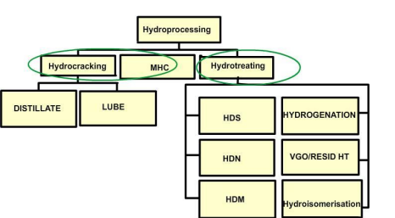
Figure 5. Chemistry of Hydro processing

Hydro processing Techniques:

Table 6. Hydro pressing Techniques for different range of feedstock’s

Feed Stocks | Products | Types of Process | Impurities Removal
Naphtha | - Reformer Feed  - LPG | Hydro treating  Hydrocracking | S
Atmospheric Gas Oil | - Diesel  - Jet Fuel | Hydro treating  Mild Hydrocracking | S, aromatics  S, aromatics
Vacuum Gas Oil | - Naphtha  - Low Sulphur fuel oil(LSFO)  - FCC Feed  - Diesel  - Kerosene/Jet Naphtha  - Lube Oil | Hydrocracking  Hydro treating  Hydro treating  Hydro treating, Hydrocracking  Hydro treating  Hydro treating | S  S  S, N, metals  S, aromatics  S. aromatics  S, N, aromatics
Residuum | - LSFO  - FCC Feedstock  - Coker feedstock  - Diesel | Hydro treating  Hydro treating  Hydro treating  Hydrocracking | S  S, N, CCR and metals  S,CCR and metals

3.1. Hydro Treating

Hydro treating units are needed in the refinery to clean streams from material such as sulphur, nitrogen or metals harmful to the catalysts. That is why they are located before the reformer, hydrocracker and FCC. They are also needed to adjust the final product specification for various streams, such as light naphtha, kerosene and low sulphur fuel oils (LSFOs). Hence, the main role of hydro treating can be summarized as follows:
- Meeting finished product specification:
- Kerosene, gas oil and lube oil desulphurization.
- Olefin saturation for stability improvement.
- Nitrogen removal.
- De-aromatization for kerosene to improve cetane number, which is the percentage of pure cetane in a blend of cetane and alpha-methyl-naphthalene. The latter matches the ignition quality of kerosene sample.
- Feed preparation for downstream units:
- Naphtha is hydrotreated for removal of metal and sulphur.
- Sulphur, metal, polyaromatics and Conradson carbon removal from vacuum gas oil (VGO) to be used as FCC feed.
- Pretreatment of hydrocracking feed to reduce sulphur, nitrogen and aromatics.

3.1.1. Chemistry of Hydro Treating
Petroleum fraction contains foreign elements, such as S, N, O, and Cl, which can be removed by hydrotreating. Hydrotreating is also used to transform unsaturated compounds to the corresponding saturated hydrocarbons. Sometimes it is used to safeguard the catalyst from metals and organo-metallic compounds by providing a cheap guard catalyst where metals are deposited. Hydrotreating reactions can be classified as follows:
1. Desulphurization
a. Mercaptanes:
b. Sulphides:
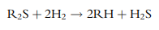
c. Disulphides:
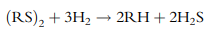
d. Thiophenes:
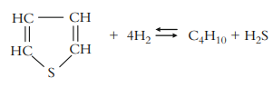
2.Dinitrogenation:

a. Pyrrole:
b. Pyridine:
3.Deoxidation:
a. Phenols:
b. Peroxides:
4.Hydrogenation of Chlorides:
5.Hydrogenation of Olefins:
6.Hydrogenation of Aromatics:
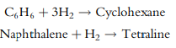
7. Hydrogenation of organo-metallic compounds and deposition of metals:
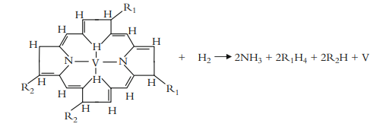
Vanadium deposited as vanadium sulphide (V₂S₃)
8.Coke formation by the chemical condensation of polynuclear radicals:

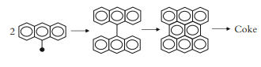

3.1.2. Hydro Treating Catalyst:
The hydrotreating catalyst is a porous alumina matrix impregnated with combinations of cobalt (Co), nickel (Ni), molybdenum (Mo) and tungsten (W). The catalysts mainly have pores with a surface area of (200–300 m2 /g). Co–Mo catalysts are the most popular for desulphurization of straight run petroleum fractions. Ni–Mo catalysts are chosen when higher activity is required for the saturation of polynuclear aromatic compounds or for the removal of nitrogen and refractory sulphur compounds, while Ni–W catalysts are chosen only when very high activity aromatic saturation is required. The pore size of a catalyst should be chosen carefully because a smaller size will favour hydrodesulphurization (HDS) on the expense of hydrodemetallization (HDM).

Table 7. Reactivities of hydro treating catalysts
Catlayst | Hydro-desulphurization | Hydro-Denitrogenation | Aromatics  hydrogenation
Co-Mo/Alumina | Excellent | Good | Fair
Ni-Mo/Alumina | Very Good | Very Good | Good
Ni-W/alumina | Good | Good | Excellent

In the case of a guard reactor, which is used to protect the main catalyst from metal deposition, catalysts with wide pores are chosen and are generally plugged by metal deposition. Catalysts are available in several different compositions and reactivity.
Cobalt–molybdenum (Co–Mo) and nickel–molybdenum (Ni–Mo) catalysts resist poisoning and are the most universally applied catalysts for hydrodesulphurization of feedstocks ranging from naphtha to residue. In addition, they promote both demetallization and desulphurization. The vanadium deposition rate at a given desulphurization level is a function of the pore structure of the alumina support and the types of metals on the support.

3.1.3. Hydro Treating Process:
In hydro treating processes, the liquid feed is mixed with hydrogen and fed into a heater and the mixture is brought to the reaction temperature in a furnace and then fed into a fixed bed catalytic reactor. The effluent is cooled and hydrogen-rich gas is separated using a high pressure separator. Before the hydrogen is recycled, hydrogen sulphide can be removed using an amine scrubber. Some of the recycle gas is also purged to prevent the accumulation of light hydrocarbons (C1–C4) and to control hydrogen partial pressure. The liquid effluent for the reactor is introduced to a fractionator for product separation.
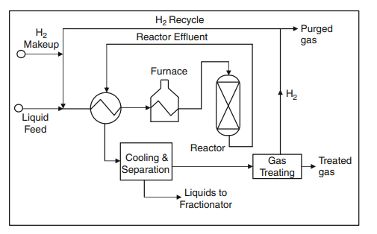
Figure 6. The main elements of a Hydro Treating Process

3.1.4. Naphtha Hydro Treating Process:
Heavy naphtha hydrotreating is usually used to remove the impurities so that the hydrotreated naphtha can be introduced to the catalytic reformer. The expensive platinum based catalyst used in the reformer is sensitive to poisoning by such impurities. The naphtha reformer consists of a feed heater, reactor, high and low pressure separators, recycle compressor and treated naphtha fractionator. A hydrogen sulphide scrubber might be placed between the high and low pressure separators. Some of the recycled gas is purged to lower the concentration of light hydrocarbon (C1–C4). A catalyst of Co–Mo on alumina is used.
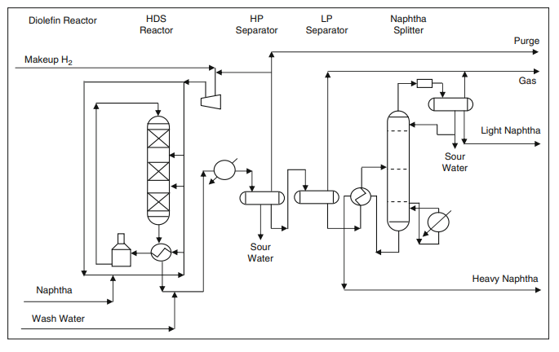
Figure 7. Naphtha Hydro Treating
3.1.5. Operating Conditions for Hydro Treating

Table 7. Range of operating conditions for hydro treating of different feed fractions

Feed stock | Naphtha | Kerosene | Gas Oil | Vacuum Gas Oil | Residue
Boiling range, o C | 70-180 | 160-240 | 230-350 | 350-550 | >550
Operating temperature, o C | 260-300 | 300-340 | 320=350 | 360-380 | 360-380
Hydrogen pressure, bar | 5-10 | 15-30 | 15-40 | 40-70 | 120-160
Hydrogen consumption, wt% | 0.05-0.1 | 0.1-0.2 | 0.3-0.5 | 0.4-0.7 | 1.5-2.0
LHSV, hr⁻¹ | 4-10 | 2-4 | 1-3 | 1-2 | 0.15-0.3
H2/HC ratio, std m3 /m3 | 36-48 | 36-48 | 36-48 | 36-48 | 12-24

3.2. Hydrocracking

Hydrocracking is a catalytic hydrogenation process in which high molecular weight feedstocks are converted and hydrogenated to lower molecular weight products. The catalyst used in hydrocracking is a bifunctional one. It is composed of a metallic part, which promotes hydrogenation, and an acid part, which promotes cracking. Hydrogenation removes impurities in the feed such as sulphur, nitrogen and metals. Cracking will break bonds, and the resulting unsaturated products are consequently hydrogenated into stable compounds.
Hydrocracking plays an important role as one of the main conversion processes. It is mainly used to produce middle distillates of low sulphur content such as kerosene and diesel. If mild hydrocracking is used, a LSFO can be produced. More recently, it has been used to remove wax by catalytic dewaxing and for aromatic removal by hydrogen saturation. This has been applied to the lube oil plants and is gradually replacing the old solvent dewaxing and aromatic solvent extraction.
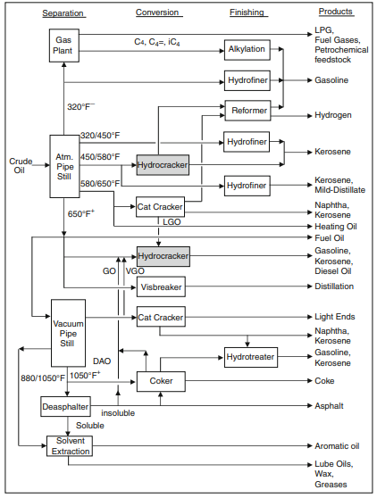
Figure 8. Role of Hydrocracker in the Refinery
3.2.1. Hydrocracking Feed and Products:

VGO is the main feed for hydrocrakers, however a variety of feeds can be used. The feedstock type has an important influence on the final products.
Table 8. Hydrocracker Feeds and Products

Feed Stocks | Products
Kerosene | Naphtha
Straight-run diesel | Naphtha and/or jet fuel
Atmospheric gas oil | Naphtha, jet fuel, and/or diesel
Vacuum gas oil | Naphtha, jet fuel, diesel, lube oil
FCC LCO | Naphtha
FCC HCO | Naphtha and/or distillates
Coker LCO | Naphtha and/or distillates
Coker HCO | Naphtha and/or distillates
Deasphalted oil | Olefin plant feedstocks

3.2.2. Chemistry of Hydrocracking:

- Alkyl Hydrocracking
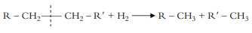
- Hydro Dealkylation
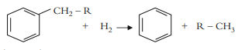
- Ring opening

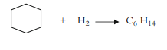
- Hydroisomerization
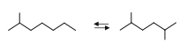
- Polynuclear aromatics by Hydrocracking
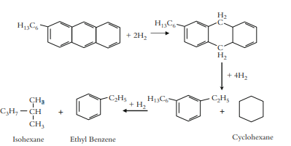

3.2.3. Hydrocracking Catalyst:

Hydrocracking catalysts have a cracking function and a hydrogenation– dehydrogenation function. The cracking function is provided by an acidic support, whereas the hydrogenation–dehydrogenation function is provided by active metals. The acidic support can be (a) amorphous oxides (e.g. silica–alumina), (b) a crystalline zeolite (mostly modified Y zeolite) plus binder (e.g. alumina) or (c) a mixture of crystalline zeolite and amorphous oxides. Cracking and isomerization reactions take place on the acidic support.

The metals providing the hydrogenation–dehydrogenation function can be noble metals (palladium, platinum) or non-noble metal sulphides from Group VI.A (molybdenum, tungsten) and group VIII.A (cobalt, nickel). These metals catalyze the hydrogenation of the feedstock, making it more reactive for cracking and heteroatom removal and reducing the coking rate. They also initiate the cracking by forming a reactive olefin intermediate via dehydrogenation. The ratio between the catalyst’s cracking function and hydrogenation function can be adjusted to optimize activity and selectivity. The relative strength of different hydrogenation components and cracking (acid) components in hydrocracking catalysts.
Catalysts with amorphous supports are still in commercial use, primarily where maximizing the production of middle distillates or conversion to lube oil blending stock are the objective. Amorphous hydrocracking catalysts contain primarily amorphous silica–alumina. The hydrocracking catalysts described so far are used primarily for hydrocracking gas oils and FCC cycle oils. For hydroprocessing residues, amorphous hydrocracking catalysts as well as specially designed hydrotreating catalysts and iron-containing catalysts are used.
Catalysts used for mild hydrocracking have a composition similar to that of hydrotreating catalysts. They consist of Group VI and VIII non-noble metals supported on g-alumina. The metals used are cobalt, nickel, molybdenum, and tungsten in sulphided form. Under mild process conditions, gas oil hydrocracking catalysts may also be used for mild hydrocracking. Dewaxing catalysts usually consist of a hydrogenation metal (Pt, Pd, Ni) supported on a medium-pore zeolite (e.g. ZSM-5) combined with a binder, commonly alumina. A zeolite catalyst Y type. The reacting molecules pass inside the cages and are brought in close contact for reaction. The zeolite channels (or pores) are microscopically small and in fact have molecular size dimension such that they are often termed as molecular sieves.
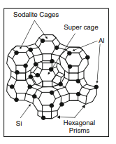
Figure 9. Structure of Y-type zeolite catalyst

3.2.4. Hydrocracking Process:
The following factors can affect operation (product quality), yield (quantity), and the total economics of the process:
- Process configuration: one stage (once-through or recycle) or two stages
- Catalyst type
- Operating condition (depends on process objective)
- Conversion level
- Maximization of certain product
- Product quality
- Catalyst cycle
- Partial hydrogen pressure
- Liquid hourly space velocity
- Feed/hydrogen recycle ratio

One – Stage Hydrocracking Process

The one-stage process can be used for light feeds with once through or recycle process. In commercial hydrocrackers, a conversion of 40–80% of the feed can be achieved. However if high conversion is required the product from the bottom of the distillation tower is recycled back to the reactor for complete conversion. This configuration can be used to maximize a diesel product, and it employs an amorphous catalyst.
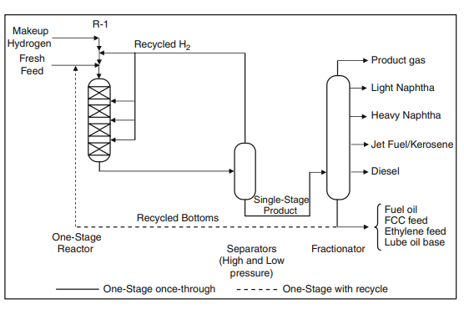
Figure 10. One Stage Hydrocracking Process

Two- Stage Hydrocracking Process:

In the two-stage operation, the effluent from the first stage reactor is sent to a separator and fractionator. The fractionator bottoms are sent to the second reactor. In both configurations, the hydrogen is separated in the high pressure separator and recycled back to the reactor. The hydrocracking catalyst in the first stage has a high hydrogenation/acidity ratio, causing sulphur and nitrogen removal. In the second reactor, the catalyst used is of a low hydrogenation/acidity ratio in which naphtha production is maximized. However, if middle distillate, kerosene, diesel and jet fuel are to be maximized, a high hydrogenation/acidity ratio is used. A hydrotreatment reactor may be added before the first hydrocracker to help in removing sulphur and nitrogen compounds from the feed. Since H2S and NH3 are separated before entering the second hydrocracker, this allows the selection of special catalysts in the second reactor without the poisoning effect of sour gases. This will allow deep hydroconversion. The two-stage configuration offers more flexibility than the single stage scheme. It is better suited for heavy feedstocks.

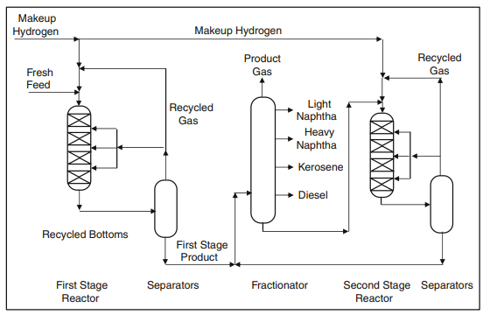
Figure 11. Continuous two stage Hydrocracking unit
    - Operating Conditions for hydrocracking
Table 9. Comparison of operating conditions of mild hydrocracking, and conventional hydrocracking
Operating Conditions | Mild Hydrocracking | Hydrocracking
Conversion (%) | 20-70 | 70-100
H2 pressure (bars) | 35-70 | 85-140
H2 flow (L/min) | 300-1000 | 1000-2000
Temperature (C) | 350-440 | 350-450
LHSV(h⁻¹) | 0.3-1.5 | 0.5-2.0
Hydrogen transfer  (Metal) | Ni/Mo  Co/Mo | Ni/Mo  Ni/W-Pd
Support | Alumina | Si-Al
Cracking(acid) | Si-Al | Zeolite

- Experimental Analysis
4.1. Catalytic Loading
Refineries change out catalysts periodically, reloading either with fresh or regenerated used catalysts. Loading schemes include two or more catalysts. For every changeout or loading, the question must be answered: which catalyst or catalyst combination is most appropriate for the next cycle of the unit?
Choosing the best catalyst is of crucial importance. It relates directly to the profitability of the refinery, and therefore represents a tremendous opportunity for increasing refining margins. It has a huge impact on both daily operations and long term planning. For hydrocrackers, such a decision will have a major effect on the economics of the refinery.
In recent years, comparative catalyst testing in pilot plants has become the best practice for evaluating catalyst performance and the profit impact of process options. When selecting catalysts, refiners consider several factors: expected performance, price, guarantees, technical service, and previous experience with prospective suppliers.

Important performance parameters include:
• Catalyst activity
• Yields (selectivity)
• Catalyst cycle life
• Deactivation rate
• Hydrogen consumption/ production
• Product properties
• Yield flexibility
• Feedstock flexibility (including feed rate changes)
• Pressure drop build-up (dP+).

4.1.1. Process parameters for pilot plant studies
  - Feedstock quality
Refiners frequently change feedstocks before determining the impact of such changes in a pilot plant study. Failure to do so can be exceedingly expensive.
Most refinery planning models assume that all hydrocracker feeds give the same product distribution, regardless of endpoint. They predict that raising feedstock endpoints can be equivalent to converting heavy fuel oil into naphtha and middle distillates. Over small ranges, most vendor kinetic models give similar results. But in fact, especially for FCC heavy cycle oil and heavy coker gasoil, raising endpoints by just a few degrees can be equivalent to pumping liquid coke into the unit. Deactivation accelerates. Conversion drops immediately. To reattain conversion, temperatures must be increased accordingly. The incremental conversion is largely thermal, giving relatively large amounts of gas. In cases where this has happened, a pilot plant test readily would have revealed the impacts in advance.

  - Catalyst activity
In practice, catalyst activity in fixed bed systems refers to the average temperature required to achieve one or more major primary process objectives, such as sulphur removal or conversion of high boiling fractions into lighter fractions. In lube base stock hydroprocessing, primary objectives may include aromatics saturation, wax removal, or colour stabilisation. Typically, refiners base operations on weighted average bed temperature (WABT) or catalyst average temperature (CAT). Average temperatures are used because hydroprocessing units are adiabatic.
Catalytic reforming is endothermic; temperatures go down as feeds pass through the reactors. Hydrotreating and hydrocracking are exothermic; temperatures go up as feeds pass through the reactor(s).

  - Catalyst deactivation
As catalysts age, they lose activity as coke deposition fouls active sites. Hydrogen inhibits coke formation, so increasing hydrogen partial pressure (H2PP) decreases coke- induced deactivation. Feed contaminants and process upsets also cause deactivation. To compensate for activity loss, operators increase temperature to maintain performance (for instance, sulphur removal or conversion).
Deactivation rate can be expressed as temperature increase requirement (TIR) expressed as degrees per unit of time. Consider the following sample calculation. A diesel hydrotreater can make ultra low sulphur diesel (ULSD) at a WABT or CAT of 360°C at the start of a cycle. Due to metallurgical constraints, the maximum average temperature is 425°C. If the TIR is 2°C per month, the projected catalyst life (barring upsets or unacceptable pressure drop) is 2.7 years. A tacit assumption here is that deactivation is linear. In fact, TIR tends to increase, especially at higher temperatures near end of run.

  - Yields (selectivity)
Yields and selectivity are closely related. A typical refinery yield report includes the following:
• Methane (C1)
• Ethane (C2)
• Propane (C3)
• Butanes (i-C4 and n-C4)
• Light olefins (propylene and butylenes)
• Light naphtha (primarily pentanes) defined with a boiling range
• Heavy naphtha
• Light gasoil (may also be called kerosene)
• Heavy gasoil
• Unconverted oil
• Hydrogen

Yield tables show results in both wt% of feed and vol% of liquid feed. The sum is 100 wt% plus H2 consumption or production (wt%).
Selectivity is the relative yield of a product or group of products. Selectivity calculations might exclude unconverted oil. So-called ‘gas make’ is C1+C2+C3. Naphtha selectivity is the sum of light and heavy naphthas. Middle distillate selectivity is the sum of light and heavy gas oils.
With respect to selectivity, hydrocracking can be quite flexible. For a given catalyst, operating conditions can be adjusted to emphasise either naphtha or middle distillates.

4.2. Catalyst Loading Procedure
In Catalytic loading, we have three sections in the reactor:
    - Pre-heating section
    - Catalyst Section
    - Post heating section
Pre heating and post heating sections are made up of alumina beds. These section are heated because
Catalyst sections is maintained at a very high temperature around 375-450 oC. To maintain the fluid movement from top to the bottom of the reactor section, these alumina bed sections are maintained
In the catalyst section, there are usually different combinations of catalyst are loaded together to achieve the desired results. In this, we use silicon carbide in between the catalyst to increase the bed height and silicon carbide also helps in preventing any losses.
Before loading the catalyst, reactor internals should be inspected so that no water is present. Catalyst should not be loaded until all traces of water are removed. Displace moist air in the reactor by using dry instrument air. During the catalyst loading, the catalyst may be exposed to steam, rain, fog, cooling tower mist, etc. The catalyst must be loaded carefully, as rough handling may cause breakage & produce fines, which can result in pressure drop problems. SiC is added to catalyst bed to fill the voidage. The volume of SiC is 1/3rd of catalyst volume. Glasswool is required to be provided between two consecutive beds. Catalyst loading must be done according to the loading pattern which is project & requirement specific.

4.2.1. Measures to be taken in consideration
- Feed & product tanks should be cleaned & empty.
- The performance of mass flow controller should be checked at different gas flow rates by directly connecting its outlet to the inlet of wet gas meter.
- Insulation should be proper along lines.
- Check for cooling water supply.
- Air, hydrogen & nitrogen compressors should be trouble free.
- Caustic scrubber packing can be cleaned to remove salt deposits.
- Sufficient coolant for re-circulating chillers & their functioning.

4.2.2. Procedure to be followed for loading Catalyst
The catalyst and diluents are generally loaded in the reactor as per the procedure briefly outlined below.
  - Initially, a 2 cm glass wool plug is used so as to assure that the alumina balls above do not flow out of the bed and also to give a proper distribution to the liquid flowing down.
  - Then Alumina balls are inert support to the catalyst bed. Also this inert bed helps to minimize the heat losses from the catalyst bed. The alumina balls bed height is adjusted to the catalyst bed height.
  - The catalyst is then loaded to the reactor. For the experiments where diluents are also added, initially half of the catalyst and diluent is added and then the reactor is vibrated mildly. Then the remaining catalyst and the diluents are added and the reactor is again mildly vibrated allowing the diluents to settle in the void of the catalyst bed. The height of the catalyst bed is dependent on the diluents size and volume used.
  - 2 cm glass wool plug was again introduced for the same aforesaid reason.
  - Alumina balls are then introduced at the top of the catalyst bed to ensure the proper distribution of feed over the catalyst bed and also to minimize the heat losses from the reactor exposed to the atmosphere.
  - The distributors at the top and the bottom of the reactor helped for the proper distribution of the feed over the bed.
4.2.3. Pressure Testing
Wherever a catalyst is loaded in a reactor, the entire high pressure gas loop should be checked for leakage by pressurizing the loop initially with N2 upto 20 to 30% higher than the normal operating pressure and maintained under pressurized condition for 24 hrs. Once pressure testing is within the permissible pressure drop (0.2 bar/hr max under N2 atmosphere), the above procedure has to be repeated with hydrogen. During pressurization, it is highly recommended to perform this activity through MFC only.

4.2.4. Sulfiding Test
Sulfide / activate the catalyst as per the sulfiding procedure. Sulfiding procedure is catalyst specific & normally suggested by the catalyst vendors / technology licensors, etc. Sulfiding procedure is also provided in the Run Instruction.
After completion of sulfiding, charge the fresh feed viz., Diesel etc. In feed tank by emptying sulfiding feed. Follow the run instructions to conduct the experimental program in the unit.

General Sulfiding Procedure:
Sulfiding of the catalyst is required as the commercial catalyst available from the market is in oxide form. Before the process started, drying and sulfiding is done in the following way:

  - System is pressurized with set H2 flow.
  - Catalyst bed temperature to be increased. This is done to dry the catalyst bed so as to ensure the removal of any moisture from the bed which is undesirable.
  - Hold at this condition for few hours.
  - Soak the catalyst bed with SRGO having DMDS so that oil reaches into the pore of the catalyst.
  - After completion of soaking, feed rate and hydrogen flow rate are increased as desired.
  - Catalyst bed temperature is also increased and then the bed is held at these conditions for few hours so as to ensure the sulfiding of the catalyst.

Remember: Sulfiding of the catalyst is carried out because of the reason that the commercially available catalyst is in the oxide form that cannot be directly used without
Sulfiding for the process to be carried out.

5. Safety Considerations in Petroleum Refinery
Safety is of extreme importance in all petroleum refineries. Every employee is involved in developing the regulations and procedures for work safety. In this way, anyone who works in the refinery is part of the safety system and will always be sure to work safely and help others work safely. All routine jobs in the refinery should conform to high safety standards. No work can be carried out without a permit. This is in order to ensure that personnel always know where work is being done and, therefore, they can prevent jobs from overlapping.Whenever workers are in the refinery site, they have to wear safety clothing known as personal protective equipment (PPE).

  - Hazards in Petroleum Refinery:
    - Crude oil Pre –Treatment
- Hydrogen sulphide, hydrogen chloride and salts in the desalter are the main causes of corrosion in the unit.
- Corrosion is the source of leakage of oil and evaporated hydrocarbons.
- Low boiling point hydrocarbon leaks can possibly lead to fires and explosions in the unit.
- Scheduled maintenance is required to prevent salt fouling and corrosion.
    - Crude oil Distillation
- Low boiling point hydrocarbons may leak from improper connections between furnace, heat exchangers and distillation column.
- When the hydrocarbon leaks find any source of ignition, a fire and/or an explosion may occur.
- Thermal cracking is the source of coke formation which may block lines and connections leading to over-pressurising and sometimes unit failure and consequent shut down.
- Coke formation can be prevented by controlling the temperature and pressure
- Sour crude distillation, especially at a high temperature of 232 C (450 F), causes severe corrosion.
- Anti-corrosive chemicals and sufficient wash water are injected to avoid corrosion.
    - Catalytic Reforming
- Catalyst handling and loading should be based on standard operating procedure so as not to crush the catalyst leading to fine particulates that may either escape into the atmosphere or be deposited in the reformer lines and connections.
- Hydrogen chloride and ammonium chloride may form in the unit pre-heater which can lead to fouling and corrosion.
- Scheduled maintenance is required to prevent corrosion and ensure the temperature is controlled to avoid hot spots in the reactor.

    - Thermal Cracking
- When sour crude is processed in the delayed coking unit, procedures must be carried out carefully to prevent corrosion, since the unit is working at high temperatures between 232 and 482oC (450 oF and 900 oF).
- Above 482 oC (900 oF) steam is injected to prevent coke formation in the lines. Scheduled maintenance is required to ensure that the temperature control units are working properly.
- Hydrogen sulphide corrosion may occur in the furnace, coking drums and reactors.
- Water jets used for coke removal from the coke drum should be drained properly and completely to avoid explosion when fresh coke forms again during operation.
    - Hydro treating and Hydrocracking
- Catalyst handling and loading must be carried out with care so that fine particles from crushed catalyst are not produced.
- Fine particulates may result in a dust explosion. Since hydrogen sulphide is present regular maintenance is required to avoid corrosion.
- A high operating temperature leads to coke formation on the catalyst; therefore, care should be taken during the catalyst regeneration process to avoid fire and explosion.
    - Fluid Catalytic Cracking
- Catalyst handling and loading should be based on the standard operating procedure to prevent catalyst dust explosion.
- Oil coating the spent catalyst should be stripped out in the stripper section of the reactor before sending it to the regenerator.
- If not removed, the presence of this oil will cause explosion during contact with air in the regenerator.
- Hydrocyclones must be carefully operated, otherwise catalyst fines will be carried out over to the distillation column. These fines will be concentrated in the decant oil.
    - Alkylation
- In the alkylation unit, two systems are used, either sulphuric acid or hydrofluoric acid, which are both considered hazardous chemicals.
- Material handling with extreme care is required especially the hydrofluoric acid during cleaning processes in which water is used.
- Improper contact of the acid with water may lead to an explosion. A concentrated acid is used with small amounts of water to avoid corrosion.
- Acid effluent must be neutralised before it is sent to the sewers.
    - Hydrogen Production
- Scheduled maintenance is required to prevent corrosion and ensure that temperature and pressure are controlled.
- This must be done in order to avoid hot spots in the reactor.
- Low boiling point hydrocarbons released from a leak may lead to a fire and/or an explosion.
- Inspections for piping and connections should be done regularly to assure hydrogen production quality.

  - Safety programs and Regulations
Regulatory agencies such as the Occupational Safety and Health Administration (OSHA) (OSHA, 2004) and the Chemical Safety and Hazard Investigation Board (CSIB) in the United States set safety regulations and accident investigation procedures to ensure work safety in industrial environments. Refining processes have special safety requirements due to the handling of crude oil and flammable hydrocarbons. Recently, every refinery began making its own safety programs based on its processing scheme, environmental regulations and manpower.

  - Hazard Analysis
Regulatory agencies such as the Occupational Safety and Health Administration (OSHA) (OSHA, 2004) and the Chemical Safety and Hazard Investigation Board (CSIB) in the United States set safety regulations and accident investigation procedures to ensure work safety in industrial environments. Refining processes have special safety requirements due to the handling of crude oil and flammable hydrocarbons. Recently, every refinery began making its own safety programs based on its processing scheme, environmental regulations and manpower.
    - HAZOP Case Study
HAZOP is defining hazards key words, consequences, causes and actions to be done to prevent an assumed hazardous scenario. HAZOP can be applied on units such as reactor, vessel or fractionator as a study node. In addition, HAZOP can be performed on a line in the flow sheet that includes valves and pumps. Cooling lines can be considered as HAZOP study node.
HAZOP procedure uses the following steps to complete an analysis:
- Choose a study node in the P&ID.
- Select a process parameter such as flow, pressure or temperature.
- Apply the HAZOP guide words (none, more of, less of, etc) to the process.
- Determine possible causes for each deviation of the process parameter.
- Record the consequences of each deviation.
- Recommend an action to avoid this deviation.
    - Safety Considerations in Plant Layout
Plant layout is often a compromise between a number of factors, including safety aspects such as:
- The geographical limitations of the site.
- The distances for transfer of materials between plant and storage units to reduce costs and risks.
- Interaction with existing or planned facilities on site such as existing roadways, drainage and utilities routings.
- The spaces for plant operability and maintainability.
- The hazardous and flammable material storages.
- Emergency services and escape routes for on-site personnel.
- The need to provide acceptable working conditions for operators.
- Preventing and/or mitigating the escalation of adjacent events (domino effect).
- Ensure that safety within on-site and off-site occupied buildings is maintained.
- Controlling the access of unauthorised personnel.

Hazard assessment of site layout is critical to minimise consequences of loss of containment and chances of escalation. The Domino effect may be by fire, explosion or toxic gas cloud causing loss of control of operations in another location.
The spread of fire from its origin to other parts of the premises can be prevented by vertical and horizontal compartments using fire-resisting walls and floors. Consideration should also be given to the spread of flammable material via drains, ducts and ventilation systems. Delayed ignition following a release may result in the spread of flames.
Protection against domino effects by convection, conduction and radiation can be achieved by inherent safety principles, that is, ensuring that the distances between plant items are sufficient to prevent overheating of adjacent plants, therefore compromising the safety of those plants. Where this is not possible due to other restrictions, other methods, such as fire walls and active or passive fire protection, may be considered.
Plant Layout design techniques applicable to the reduction of the risks from release of flammable or toxic materials include:
- Locating the storage of flammable/toxic material outside process areas.
- Locating hazardous plants away from main roadways through the site.
- Fitting remote-actuated isolation valves where high inventories of hazardous materials may be released into vulnerable areas.
- Allowing for the provision of dykes and sloping terrain to contain releases, increase the safety and reduce environmental effects.
- Siting of plants within buildings as secondary containment.
- Siting of plants in an open air environment to ensure rapid dispersion of minor releases of flammable gases and vapours and thus prevent concentration build-up which may lead to flash fires and explosions.
- Hazardous area classification for flammable gases, vapours and dusts to designate areas where ignition sources should be eliminated.
    - Fire and Explosions:
Accidental vapour cloud explosion hazards are of great concern to the refining and chemical processing industry, and a number of catastrophic explosion accidents have had significant consequences in terms of death, injury, property damage, loss of profit, and environmental impact.

Fuel-air explosives (FAE) disperse a cloud of fuel which is ignited by a source to produce an explosion. The main destructive force of FAE is high over-pressure. For fuel vapour cloud explosion, there is a minimum ratio of fuel vapour to air below which ignition will not occur. Also there is a maximum ratio of fuel vapour to air, at which ignition will not occur. These limits are the lower (LEL) and upper explosive limits (UEL). For gasoline vapour, the typical explosive range is from 1.3 to 6.0 mol% vapour to air, and for methane, this range is 5–15 mol%. Flammability limits are related to explosive limits since most explosions are followed by fire. The mass and type of material released contribute to the potential damage from a vapour cloud explosion.

    - Emergency Alarms:
Alarm systems alert operators to plant conditions, such as deviation from normal operating limits and to abnormal events, which require timely action or assessment. Alarm systems are not normally safety related, but they do have a role in enabling operators to reduce the demand on the safety related systems, thus improving overall plant safety. Guidelines for alarm systems are as follows:
- The alarm system should be designed in accordance to the designated reliability.
- The alarm system should be independent from the process control system and other alarms unless it has also been designated safety related.
- The operator should have a clear written alarm response procedure for each alarm (simple, obvious and invariant) on which he is trained.
- Each alarm should be distinguished from other alarms and remain on view at all times when active.
- The operator responsible for responding to the alarm should not be overloaded.

    - Noise in Refinery
A noise impact assessment measures the amount of noise (a noise level) coming from a particular work and compares it against a noise limit. Noise limits are usually compared to the Environment Protection Agency (EPA) guidelines. Further, assessing noise is a complex process and involves measuring background noise so that noise limits can be determined. Then the work noise levels should be measured to see its impact on the background noise levels. Background noise is measured at various locations during the daytime, evening and night time. Background noise in a refinery is basically all the noise a person can hear, other than noise coming from the industry. For example, noise from the highway is considered background noise, but noise from a nearby factory is not. Once the background noise is measured, consultants then calculate the noise limit for each location. It is important to note that noise limits change depending on the time of the day and also on the area location and activities.

  - Safe Operation Systems
The refinery must provide a safe workplace and safe products. All accidents can be preventable. Safety regulations and procedures address employee health through working in the proper environment. In addition, the refinery is responsible for the nearby environment, which includes residents and properties. Typical systems to maintain safe operations include pressure relief, flare relief and air, water and solid emissions monitoring systems.

    - Pressure Relief Systems
Over-pressurisation can upset normal operating conditions. Relief valves are installed in the lines where over-pressurisation is possible. The relief device has a set point pressure which is below the maximum allowable working pressure (MAWP). The pressure accumulation is the percentage increase above MAWP, while the over-pressure is the percentage increase in pressure above a set point.
Physical property data and sometimes reaction rate characteristics are required for making relief sizing calculations. A designer of relief systems must be familiar with industrial standards codes and insurance requirements. Codes of particular interests are published by the American Society of Mechanical Engineers, the American Petroleum Institute (API 520, 1994) guidelines.
    - Flare Relief Systems
Flares are sometimes used after knockout drums. The objective of a flare is to burn the gas to produce combustion products that are neither toxic nor combustible. When operating conditions change, flares may be used as part of the process to ensure that refinery equipment is operated safely. In most cases, hydrocarbons are recovered and reused in the refining process. However, in some cases, residual hydrocarbons are burned off. The flares combust hydrocarbon vapours into water and carbon dioxide. This is the most proper method of preventing hydrocarbon vapours from escaping into the atmosphere.
    - Air Emission Monitoring
The refinery maintains the commitment to reduce and eliminate emissions to the atmosphere. By running plants safely the amount of pollutants emitted into the air are reduced. Regular inspection of pumps, compressors, valves and flanges ensure that hydrocarbons do not escape into the atmosphere. To meet clean air standards, emissions from furnaces must be monitored and controlled.
    - Water Emission Monitoring
Any water that comes into contact with any raw material, product, byproduct or waste is known as process water. All process water from the refinery must receive extensive treatment and be in compliance with all local regulatory requirements. Water is used to keep the refinery product streams and equipment cool. By cooling the water in large cooling towers and re-circulating it, the amount of fresh water needed is minimized.
    - Solid Waste Monitoring
At the refinery, proper waste minimization and management is a high priority. Refinery solid wastes are typically in the form of sludge, spent process catalysts, filter clay, and incinerator ash. Sludge is generated from the Safety in Petroleum Refineries 373 gravitational separation of oil/water/solids during the storage or treatment of process wastewaters. Sludge is also generated from cooling waters segregated for treatment from other process or oily cooling waters. The refinery uses a variety of techniques to reduce or recycle waste and transform it into useful products.

- Major Refinery Products and their Specifications
6.1 Petrol
Petrol is classified by octane ratings (conventional, oxygenated and reformulated) into three grades: Regular, Midgrade and Premium.
- Regular Petrol: Gasoline having an antiknock index, i.e. octane rating, greater than or equal to 85 and less than 88.
- Mid-grade Petrol: Gasoline having octane rating, greater than or equal to 88 and less than or equal to 90.
- Premium Petrol: Gasoline having octane rating greater than 90.
Premium and regular grade motor gasoline are used depending on the octane rating. In addition, aviation gasoline, which is a complex mixture of relatively volatile hydrocarbons, is blended with additives to form suitable fuel for aviation engines.
Table 9. shows the Indian petrol specifications according to Bharat stage emission standards
Table 9. Indian Petrol Specifications
Serial no. | Characteristics | Unit | BS 2 | BS 3 | BS 4 | BS 6
1 | Density 15 °C | kg/m³ | 710–770 | 720–775 | 720–775 | 720-775
2 | Distillation
3 | a) Recovery up to 70 °C (E70)  b) Recovery up to 100 °C (E100)  c) Recovery up to 180 °C (E180)  d) Recovery up to 150 °C (E150)  e) Final boiling point (FBP), max  f) Residue max | % volume  % volume  % volume  % volume  °C  % volume | 10–45  40–70  90  -  210  2 | 10–45  40–70  -  75 min  210  2 | 10–45  40–70  -  75 min  210  2
4 | Research Octane Number (RON), min |  | 88 | 91 | 91
5 | Anti-Knock Index (AKI)/ MON, min |  | 84 (AKI) | 81 (MON) | 81 (MON)
6 | Sulphur, total, max | % mass | 500 mg/kg | 150 mg/kg | 50 mg/kg | 10 mg/kg
7 | Lead content (as Pb), max | 200 | 61.05 | 2.005 | 16.005
8 | Reid vapour pressure (RVP), max | kPa | 35–60 | 60 | 60
9 | Benzene content, max  a) For metros  b) For the rest | % volume | -  3  5 | 1 | 1
10 | Olefin content, max | % volume | - | 21 | 21
11 | Aromatic content, max | % volume | - | 42 | 35<

6.2 Kerosene
Though its use as an illuminant has greatly diminished, kerosene is still used extensively throughout the world in cooking and space heating and is the primary fuel for modern jet engines. When burned as a domestic fuel, kerosene must produce a flame free of smoke and odour. Standard laboratory procedures test these properties by burning the oil in special lamps. All kerosene fuels must satisfy minimum flash-point specifications (49 °C, or 120 °F) to limit fire hazards in storage and handling.

Jet fuels must burn cleanly and remain fluid and free from wax particles at the low temperatures experienced in high-altitude flight. The conventional freeze-point specification for commercial jet fuel is −50 °C (−58 °F). The fuel must also be free of any suspended water particles that might cause blockage of the fuel system with ice particles. Special-purpose military jet fuels have even more stringent specifications.
6.3 Diesel
The principal end use of gas oil is as diesel fuel for powering automobile, truck, bus, and railway engines. In a diesel engine, combustion is induced by the heat of compression of the air in the cylinder under compression. Detonation, which leads to harmful knocking in a gasoline engine, is a necessity for the diesel engine. A good diesel fuel starts to burn at several locations within the cylinder after the fuel is injected. Once the flame has initiated, any more fuel entering the cylinder ignites at once.
Straight-chain hydrocarbons make the best diesel fuels. In order to have a standard reference scale, the oil is matched against blends of cetane (normal hexadecane) and alpha methylnaphthalene, the latter of which gives very poor engine performance. High-quality diesel fuels have cetane ratings of about 50, giving the same combustion characteristics as a 50-50 mixture of the standard fuels. The large, slower engines in ships and stationary power plants can tolerate even heavier diesel oils. The more viscous marine diesel oils are heated to permit easy pumping and to give the correct viscosity at the fuel injectors for good combustion.

Until the early 1990s, standards for diesel fuel quality were not particularly stringent. A minimum cetane number was critical for transportation uses, but sulfur levels of 5,000 parts per million (ppm) were common in most markets. With the advent of more stringent exhaust emission controls, however, diesel fuel qualities came under increased scrutiny. In the European Union and the United States, diesel fuel is now generally restricted to maximum sulfur levels of 10 to 15 ppm, and regulations have restricted aromatic content as well. The limitation of aromatic compounds requires a much more demanding scheme of processing individual gas oil components than was necessary for earlier highway diesel fuels.
6.4 Other Gases
Gaseous refinery products include hydrogen, fuel gas, ethane, propane, and butane. Most of the hydrogen is consumed in refinery desulfurization facilities, which remove hydrogen sulfide from the gas stream and then separate that compound into elemental hydrogen and sulfur; small quantities of the hydrogen may be delivered to the refinery fuel system. Refinery fuel gas varies in composition but usually contains a significant amount of methane; it has a heating value similar to natural gas and is consumed in plant operations. Periodic variability in heating value makes it unsuitable for delivery to consumer gas systems. Ethane may be recovered from the refinery fuel system for use as a petrochemical feedstock. Propane and butane are sold as liquefied petroleum gas (LPG), which is a convenient portable fuel for domestic heating and cooking or for light industrial use.
6.5 Residual Fuel Oil
Furnace oil consists largely of residues from crude oil refining. These are blended with other suitable gas oil fractions in order to achieve the viscosity required for convenient handling. As a residue product, fuel oil is the only refined product of significant quantity that commands a market price lower than the cost of crude oil.

Because the sulfur contained in the crude oil is concentrated in the residue material, fuel oil sulfur levels are naturally high. The sulfur level is not critical to the combustion process as long as the flue gases do not impinge on cool surfaces (which could lead to corrosion by the condensation of acidic sulfur trioxide). However, in order to reduce air pollution, most industrialized countries now restrict the sulfur content of fuel oils. Such regulation has led to the construction of residual desulfurization units or cokers in refineries that produce these fuels.

Residual fuels may contain large quantities of heavy metals such as nickel and vanadium; these produce ashes upon burning and can foul burner systems. Such contaminants are not easily removed and usually lead to lower market prices for fuel oils with high metal contents.
6.6 Lubricating oils
At one time the suitability of petroleum fractions for use as lubricants depended entirely on the crude oils from which they were derived. Those from Pennsylvania crude, which were largely paraffinic in nature, were recognized as having superior properties. But, with the advent of solvent extraction and hydrocracking, the choice of raw materials has been considerably extended.

Viscosity is the basic property by which lubricating oils are classified. The requirements vary from a very thin oil needed for the high-speed spindles of textile machinery to the viscous, tacky materials applied to open gears or wire ropes. Between these extremes is a wide range of products with special characteristics. Automotive oils represent the largest product segment in the market. In the United States, specifications for these products are defined by the Society of Automotive Engineers (SAE), which issues viscosity ratings with numbers that range from 5 to 50. In the United Kingdom, standards are set by the Institute of Petroleum, which conducts tests that are virtually identical to those of the SAE.
When ordinary mineral oils having satisfactory lubricity at low temperatures are used over an extended temperature range, excessive thinning occurs, and the lubricating properties are found to be inadequate at higher temperatures. To correct this, multigrade oils have been developed using long-chain polymers. Thus, an oil designated SAE 10W40 has the viscosity of an SAE 10W oil at −18 °C (0 °F) and of an SAE 40 oil at 99 °C (210 °F). Such an oil performs well under cold starting conditions in winter (hence the W designation) yet will lubricate under high-temperature running conditions in the summer as well. Other additives that improve the performance of lubricating oils are antioxidants and detergents, which maintain engine cleanliness and keep fine carbon particles suspended in the circulating oil.
6.7 Gear oil and Greases
In gear lubrication the oil separates metal surfaces, reducing friction and wear. Extreme pressures develop in some gears, and special additives must be employed to prevent the seizing of the metal surfaces. These oils contain sulfur compounds that form a resistant film on the surfaces, preventing actual metal-to-metal contact.
Greases are lubricating oils to which thickening agents are added. Soaps of aluminum, calcium, lithium, and sodium are commonly used, while nonsoap thickeners such as carbon, silica, and polyethylene also are employed for special purposes.

6.8 Other Petroleum Products
Highly purified naphthas are used for solvents in paints, cosmetics, commercial dry cleaning, and industrial product manufacture. Petroleum waxes are employed in paper manufacture and foodstuffs.

Asphaltic bitumen is widely used for the construction of roads and airfields. Specialized applications of bitumen also include the manufacture of roofing felts, waterproof papers, pipeline coatings, and electrical insulation. Carbon black is manufactured by decomposing liquid hydrocarbon fractions. It is compounded with rubber in tire manufacture and is a constituent of printing inks and lacquers.

